

# Final Year Project Report

# On

# “Hire-Hawk: An Applicant Tracking System”

##### In partial fulfilment of the requirements for the Bachelor’s Degree in

##### Computer Science and Information Technology (B.Sc. CSIT)

**Submitted By:**

**Mandip Kunwar (5-2-1131-18-2019)**

##### Mandip Kunwar (5-2-1131-18-2019) Saurabh Subedi (5-2-1131-30-2019) Shiwam Paudel (5-2-1131-32-2019)

**Swastik College**

##### Department of Computer Science and Information Technology Institute of Science and Technology

##### Tribhuvan University

##### December 2023



# Final Year Project Report

# On

# “Hire-Hawk: An Applicant Tracking System”

##### In partial fulfilment of the requirements for the Bachelor’s Degree in

##### Computer Science and Information Technology (B.Sc. CSIT)

##### Under the Supervision of

##### Sagar Rana Magar

**Submitted By:**

##### Mandip Kunwar (5-2-1131-18-2019) Saurabh Subedi (5-2-1131-30-2019) Shiwam Paudel (5-2-1131-32-2019)

**Swastik College**

##### Department of Computer Science and Information Technology Institute of Science and Technology

##### Tribhuvan University

##### December 2023

##### DECLARATION

This project entitled "Hire-Hawk" is based on our own research. Other researchers related work on this issue has been recognized. We are responsible for all liabilities pertaining to the data corrections and validity, as well as any other material contained herein.

..................................

Mandip Kunwar

..................................

Saurabh Subedi

..................................

Shiwam Paudel

##### SUPERVISOR’S RECOMMENDATION

I hereby recommend that this report prepared under my supervision by Mr. Mandip Kunwar, Mr. Saurabh Subedi and Mr. Shiwam Paudel entitled "Hire-Hawk: An Applicant Tracking System" in partial fulfillment of the requirements for the degree of Bachelor of Science in Computer Science and Information Technology be processed for the evaluation.

..................................

Mr. Sagar Rana Magar

Lecturer,

Swastik College

##### LETTER OF APPROVAL

This is to certify that, this project entitled "Hire-Hawk: An Applicant Tracking System" submitted by MANDIP KUNWAR, SAURABH SUBEDI and SHIWAM PAUDEL is partial fulfillment of the requirements for the degree of Bachelor of Science in Computer Science and Information Technology has been Studied. In our opinion, it is satisfactory in scope and quality as a project for the required degree.

|  |  |
| --- | --- |
| ……………………………  Mrs. Shristi Khatiwoda  Program Coordinator  Swastik College | ……………………………  Internal Examiner  Swastik College |
| ……………………………  Mr. Sagar Rana Magar  Supervisor,  Swastik College | ……………………………  External Examiner  IOST, Tribhuvan Univeristy |

##### ACKNOWLEDGEMENT

A project entitled "Hire-Hawk: An Applicant Tracking System" has been prepared to fulfill the requirement of the undergraduate project. The report is deeply indebted to Tribhuvan University and Swastik College for incorporating a project report in the bachelor program which provides a wonderful opportunity to carry out practical knowledge on any topic. Our forthnight gratefulness goes to the supervisor Mr. Sagar Rana Magar, program coordinator Mrs. Sristi Khatiwada, for your coordinating and supporting this project. And lastly, we are also thankful to teacher and all the people who put valuable effort to help us with this project.

Thanking you, Mandip kunwar Saurabh Subedi Shiwam Paudel

##### ABSTRACT

"Hire-Hawk: An Applicant Tracking System" represents a precise crafted solution for streamlining the complexities of job vacancy management and applicant screening. This comprehensive system ensures operational feasibility by enabling administrators to effortlessly upload job vacancies along with detailed descriptions. Simultaneously, applicants can seamlessly submit their resumes, initiating a sophisticated scoring process that assesses the compatibility between the applicant’s profile and the job requisites. The system has capability to generate scores based on resume-job description matches stands as a pivotal feature, promising efficient and effective screening mechanisms.

The project’s schedule feasibility is underscored by meticulous planning, allocating ample time across various project phases. A detailed Gantt chart delineates the development phases, emphasizing sufficient time allocated for analysis, development, and documentation. Such meticulous scheduling signifies a commitment to a thorough and unhurried development process, ensuring a robust and well-considered outcome.

Furthermore, the design phase reveals a structured approach through visual representations like Entity-Relationship (ER) diagrams, Data Flow Diagrams (DFDs), and interface designs. These elements provide a tangible glimpse into the system’s architecture, module integrations, and user interfaces, showcasing a meticulous and comprehensive design philosophy. Overall, "Hire-Hawk: An Applicant Tracking System" embodies a fusion of meticulous planning, advanced technological integration, and a user-centric design to revolutionize the landscape of job vacancy management and applicant screening.

**Keywords :** Cosine similarity Algorithm, Text Extraction, Django, Recruitment

**Table Of Contents**

List of Figures ii

List of Abbreviations iv

1. Introduction 1
   1. Introduction 1
   2. Problem Statement 1
   3. Objectives 2
   4. Scope and Limitation 2
   5. Development Methodology 3
   6. Report Organization 4
2. Background Study and Literature Review 5
   1. Background Study 5
      1. cosine similarity algorithm 5
      2. Text Extraction 6
   2. Literature Review 6
3. System Analysis 8
   1. System Analysis 8
      1. Requirements Analysis 8
   2. Feasibility Analysis 10
      1. Technical Feasibility 10
      2. Operational Feasibility 11
      3. Schedule Feasibility 11
   3. Analysis 12
4. System Design 18
   1. Design 18

References 22

# List of Figures

1.1 Visual Representation of Scrum Methodology[1] 3

2.1 Cosine Similarity 6

* 1. Use Case Diagram of Hire-Hawk: Application Tracking System 9
  2. Timeline chart for the completion of Project(Gantt Chart) 12
  3. ER Diagram of Hire-Hawk Application 14
  4. Flowchart of Hire-Hawk Application 15
  5. Level 0 DFD of Hire-Hawk Application 16
  6. Level 1 DFD of Hire-Hawk Application 16
  7. Level 2 DFD of Hire-Hawk Application 17
  8. Login Page of Hire-Hawk Application 18
  9. Signup page of Hire-Hawk Application 19
  10. Applicant dashboard page of Hire-Hawk Application 19
  11. About Job page of Hire-Hawk Application 20
  12. Score guage page of Hire-Hawk Application 20
  13. Recruiter Dashboard page of Hire-Hawk Application 21

# List of Abbreviations

|  |  |
| --- | --- |
| **HR** | Human Resources |
| **UI** | User Interface |
| **UX** | User Experience |
| **App** | Application |
| **ERD** | Entity Relationship Diagram |
| **DFD** | Data Flow Diagram |
| **ATS** | An Application Tracking System |

**Chapter 1: Introduction**

## Introduction

The "Hire-Hawk: An Applicant Tracking System" project originated from the need to streamline and modernize the recruitment process. Recognizing challenges in traditional hiring, our goal is to leverage technology for enhanced efficiency and accuracy. So this job hiring portals intends to assist system to pinpoint the eligible applicant swiftly and effortlessly without any time consuming and challenging process. This web application analyzes applied applicant resumes and assists HR in recruiting the perfect candidates for the given vacancy. This application provides the score to each applied applicant according to their knowledge and experience based on certain criteria mentioned by the companies and the candidate with the highest score is automatically displayed to the HR for the further selection of the applicant.

The “Hire-Hawk” system project is a web application that works well with maximum handheld devices. UI/UX will be pleasing to the eyes and simple to use of Google for the application user interface and Django framework using python for the Backend to keep records of the system users, store data, read and analyze the Resumes. Both help in the flexibility, simplicity, reliability, and scalability of the application. Thus, "Hire-Hawk" application analyzes and assists in enlisting the accurate and principled applicant in a rapid time without facing any burdensome and challenging process.

## Problem Statement

The traditional hiring process faces significant challenges with manual job screening and subjective candidate evaluation. Recruiters are often overwhelmed by the sheer volume of resumes, leading to time constraints and a lack of in-depth analysis. Simultaneously, job seekers encounter difficulties in effectively showcasing their skills to potential employers. "Hire-Hawk"

addresses these issues by employing the cosine similarity algorithm . This algorithm objectively assesses resumes against job descriptions, automating the screening process and ensuring a fair and efficient evaluation of candidates. By leveraging technology, "Hire-Hawk" seeks to revolutionize recruitment, offering a transparent, accessible, and equitable platform. Through the integration of the cosine similarity algorithm, the project aims to create a more streamlined and effective connection between employers and job seekers, facilitating a more efficient and accurate matching of skills to job requirements.

It will be very appreciative and pleasant if a web application analyzes and assists in enlisting the accurate and principled applicant in a rapid time without facing any burdensome and challenging process.

## Objectives

The main objective of this project should be to compare applicant’s resumes with the Job Description Text using Cosine Similarity Algorithm with the implementation of Django.

## Scope and Limitation

The "Hire-Hawk" project aims to enhance the development of a comprehensive online recruitment system. This involves enabling seamless job posting by administrators, facilitating applicant submissions, and implementing a robust scoring mechanism. The system seeks to enhance efficiency and accuracy in the hiring process. By offering an intuitive interface for both recruiters and applicants, it aspires to revolutionize job matching, providing a comprehensive and user-friendly solution to meet the dynamic demands of the recruitment landscape.

Despite its various scope, the ‘HireHawk’ application has certain limitations:

* + 1. The accuracy of the application heavily relies on the completeness and accuracy of the resumes submitted by applicants. Incomplete or misleading resumes may impact the effectiveness of the analysis.
    2. The application’s scoring system is based on the Cosine Similarity Algorithm, which may not capture certain subjective aspects of a candidate’s suitability and this application cannot replace the need for human judgment.

## Development Methodology

In building the "Hire-Hawk: An Applicant Tracking System" web app, we use Scrum Agile approach because this project requirements are dynamic, and the project is innovative and research-oriented so we used the Scrum approach to software development. The Scrum approach is well-suited for the "Hire-Hawk: An Applicant Tracking System" project as it accommodates the evolving nature of recruitment processes. Scrum is iterative cycles, or sprints, allow for regular reassessment and adaptation to changing job market dynamics. The frame- work’s emphasis on collaboration and frequent feedback ensures a responsive development process, essential for refining features like resume screening and score generation in real-time. This flexibility makes Scrum an ideal fit for the dynamic requirements of the recruitment do- main addressed by "Hire-Hawk: An Applicant Tracking System". This approach allows us to be flexible, responding to feedback and adjusting priorities as needed throughout the develop ment journey

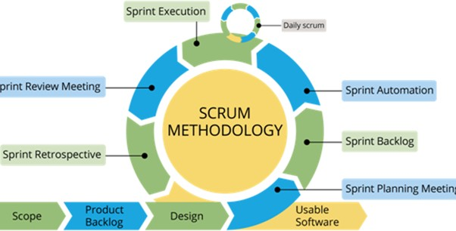

Figure 1.1: Visual Representation of Scrum Methodology[1]

## Report Organization

This Report is organized into the following six chapters. They are listed below:

* + 1. Chapter 1: Here we discuss about the Introduction of the project, the Problem statement, its objectives, scope, and limitations as well as the development methodology.
    2. Chapter 2: Here we discusses about the generation of project idea, description of fundamental theories, general concepts and terminologies related to the project as well as review of the similar/relevant projects, theories and results by other researchers
    3. Chapter 3: Here we focus on System Analysis. We first look at what the system needs to do (Functional Requirements) and the other important aspects like how it should work (Non-Functional Requirements). Project’s feasibility and Analysis (structured or object oriented) is done in this chapter.
    4. Chapter 4: Here, we discuss about system design and algorithm details according to the approach of the project which can be structured or object oriented.
    5. Chapter 5: Here we discuss about the implementation and testing process. Here in this chapter we also discuss about tools such as CASE tools, Programming languages, and Database platforms. Details of Modules are also discussed.
    6. Chapter 6: Here we discuss the conclusion of the project and future enhancement and recommendations.

**Chapter 2: Background Study and Literature Review**

## Background Study

### Cosine Similarity Algorithm

A cosine similarity measure is a metric that determines how much the two objects are alike[2]. Cosine similarity is a measure to find how similar the two documents are regardless of their size. It represents the orientation of the documents when plotted on an N-dimensional space, where each dimension depicts the features of the object. It’s a symmetrical algorithm, which implies that the results from computing the similarity of item X to item Y is equal to computing the similarity of item Y to item X. Mathematically, we can represent it as shown below in equation.

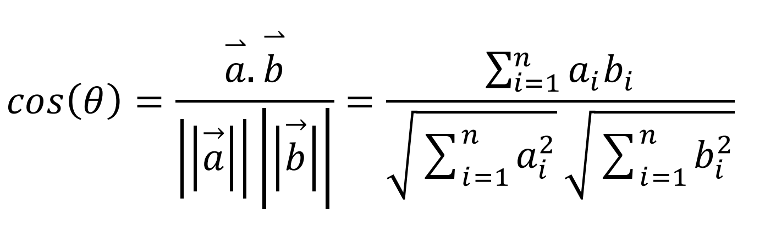

Here, →−**a** · →−**b** = *n* a*i*b*i* = a1b1 + a2b2 + . . . + a*n*b*n* is the dot product of the two vectors. Using this formula, we calculate the cosine similarity between all pairs of elements. It can then be

1

Σ

used to rank the resume documents with respect to a given vector of query words. However, cosine similarity focuses on features that are related to the text’s words only and will give less accurate results. The efficiency of similarity measures can be improved by the inclusion of semantic information. This will constitute the future scope for our automated resume screening system.

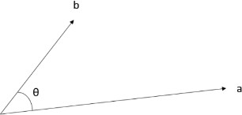

Figure 2.1: Cosine Similarity

### Text Extraction

"Hire-Hawk: An Applicant Tracking System" uses text extraction, a method to pull out essential details from resumes without diving into complex language analysis. This simplified approach focuses on key information, making it quicker for recruiters to assess candidate suit- ability. By extracting specific details rather than understanding the entire text, "Hire-Hawk: An Applicant Tracking System" ensures a faster and more accurate hiring process, benefiting both recruiters and applicants.[3]

## Literature Review

There is a growing body of research on the effectiveness of resume analysis apps. A 2002 study found that a resume analysis app based on the BERT language model was able to achieve an accuracy of 95 percent in identifying the skills and experience listed on a resume. The study also found that the app was able to accurately match candidates to job descriptions.[4],

Another study, published in 2023 found that a resume analysis app was able to reduce the time spent by recruiters on screening resumes by 50 percent. The study also found that the app was able to help recruiters identify qualified candidates who might not have been found through traditional screening methods. While the research on resume analysis apps is still in its early stages, the results so far are promising. Resume analysis apps have the potential to revolutionize the hiring process by making it more efficient and effective.[5]

The work presented as expert proposed the use of ontology mapping for screening candidates for the given job description. It included three phases of operation which were the creation of candidate ontology, construction of job criteria ontology document and then finally mapping of both of these to evaluate which candidates are eligible for the job[6].

In 2017, an automated job screening system was proposed [H.Braun]. It discussesdifferent machine learning algorithms and uses Support Vector Regression to create a list of ranked candidates for the given job[7].

Another work presented [Weathington and Bechtel, 2012] that described how social media [e.g. LinkedIn, Facebook, etc.] information of the applicants can be used for recruitment decisions[8].

**Chapter 3: System Analysis**

## System Analysis

The system analysis of the "Hire-Hawk: An Applicant Tracking System" project involves a comprehensive evaluation of its requirements, functions, and design. It encompasses activities such as data modeling using an Entity-Relationship (ER) diagram, process modeling using Data Flow Diagrams (DFD), and flowcharts. The ER diagram illustrates the relationships among different data entities, while DFDs outline the flow of information within the system. The analysis phase also involves a detailed examination of the user interfaces, emphasizing elements like login pages, dashboards, and score gauge pages.

### Requirements Analysis

"Hire-Hawk: An Applicant Tracking System" requirements should include user-friendly interfaces for applicants, and recruiters, utilizing text extraction and cosine similarity for efficient resume analysis. Security measures, performance optimization, and comprehensive documentation are integral to ensure a robust and accessible recruitment system.

##### Functional Requirements

The functional requirements of the "Hire-Hawk: An Application Tracking System" should be:

##### Authentication System:

The system should authenticate the valid admin and user along with registration with the new users.

##### User Dashboard:

Intuitive dashboards for recruiters and applicants to view and manage relevant information.

**c) Vacancy Announcement Platform:** The Admin must be able to create new vacancies as well as update and delete those vacancies.

##### d) Job Application with Resume Submission:

Applicants should be able to apply for the vacancies/jobs with their valid resume.

##### e) Score Generator and Hiring Assistance:

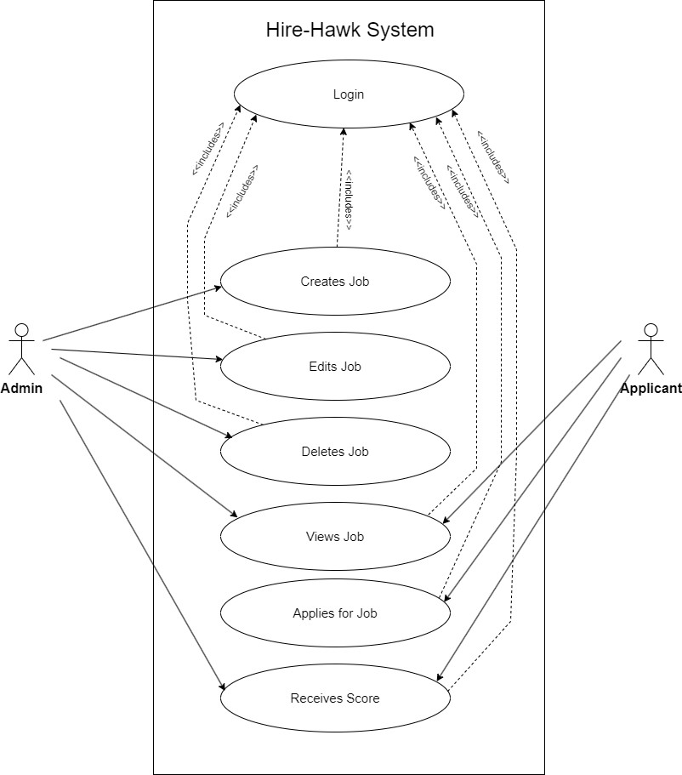The applicants can get their score based on their resume and job they applied for. Meanwhile, the admin is able to rank those applicants based on their respective scores.

Figure 3.1: Use Case Diagram of Hire-Hawk: Application Tracking System

Use case Diagram of Hire-Hawk Application Tracking System displays two actors admin and applicant where admin creates the job, edits job, views job and deletes job. In other hand, applicant views job, applies for the job and receives score based on the resume and job description.

##### Non Functional Requirements

The non functional requirements of the Hire-Hawk: An Application Tracking System should be:

##### Simple UI:

Simple, user friendly and device responsiveness user interface.

##### b) Security:

The access to the system can be done only via the valid username and password.

##### c) Accuracy:

System should able to generate the accurate score based on the resume and job description.

##### d) Usability:

Provide an intuitive and user-friendly interface for administrators, applicants, and recruiters to enhance user experience.

##### e) Scalability:

System can easily scale up to accommodate growing data and user volumes.

## Feasibility Analysis

The feasibility analysis of the "Hire-Hawk" project underscores its operational, schedule, and economic viability. Operationally, the system demonstrates technical feasibility, with all essential functions, such as job posting and resume analysis, being technically sound. The schedule feasibility is evident through meticulous time estimation and a well-structured Gantt chart, ensuring that each project activity is allotted sufficient time for analysis, development, and documentation. From an economic perspective, the project stands out by utilizing automated resume screening making the recruitment process more efficient and economically viable in the long run. Together, these factors contribute to the overall feasibility and potential success of the "Hire-Hawk" initiative.

### Technical Feasibility

The technical feasibility of the "Hire-Hawk: ATS" project involves assessing the practicality of its technological implementation.

These technologies enable efficient and automated processing of resumes, aligning with the project’s objectives. The planned user interfaces, such as login pages, dashboards, and score gauge pages, are technically feasible and designed to provide a seamless experience. The technical infrastructure, including data storage and security measures, is outlined to support the system’s functionalities. In summary, the technical feasibility analysis suggests that the chosen technologies and development approaches are suitable for realizing the objectives of the "Hire-Hawk" project.

### Operational Feasibility

The operational feasibility of the "Hire-Hawk: An Applicant Tracking System" project revolves around the practicality of its implementation. All envisioned functionalities, including job posting, resume submission, and the scoring system, have been deemed technically feasible. The integration of a text extraction system and the application of the cosine similarity algorithm for resume analysis contribute to the operational soundness of the system. Moreover, the user- friendly interface designed for administrators, applicants, and recruiters enhances operational efficiency by simplifying interactions. Overall, the operational feasibility of "Hire-Hawk" is promising, suggesting that the proposed features can be effectively implemented to create a functional and user-centric online recruitment system.

### Schedule Feasibility

For each activity of the project, proper estimation of the time is done. Overall the calculated time is sufficient to complete the project without any difficulty. This gantt chart shows the different phases and time required for the development of the Hire-Hawk. We have allocated maximum time for analysis, development and documentation of the project. The starting date of this project is on 2 October 2023 and estimated end date of the this project is 14 January 2024

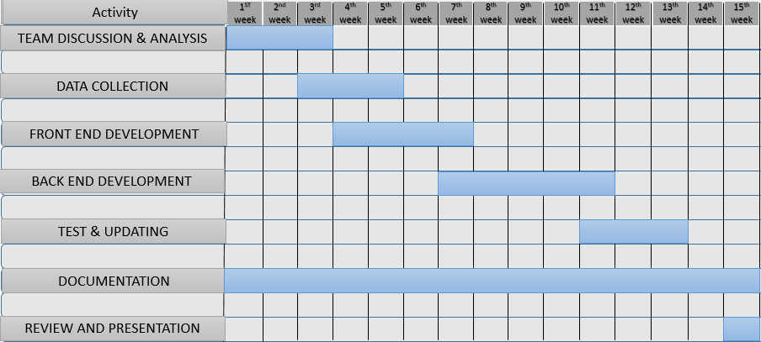

Figure 3.2: Timeline chart for the completion of Project (Gantt Chart)

## Analysis

The analysis of the "Hire-Hawk: An Applicant Tracking System" project involves a comprehensive evaluation of its feasibility, system design, and technical aspects. The feasibility analysis underscores the project’s operational, schedule, and economic viability, emphasizing the technical soundness of functionalities like job posting, resume submission, and automated scoring. The system design incorporates data and process modeling using ER diagrams and DFDs, illustrating a structured approach to recruitment. The technical feasibility is supported by the integration of text extraction and the cosine similarity algorithm, showcasing a practical and effective technological implementation. Overall, the project analysis indicates a well-planned initiative, poised to streamline recruitment processes through advanced technology and thoughtful system design

1. Data Modeling using ER Diagram

The system has three main entities Job, Applicant and User. These entities represent the fundamental components of the job application system and are interconnected through relationships that define how data flows between them. The Job entity encapsulates information about job openings. Each job description is uniquely identified by an id, and it includes attributes such as title [representing the job title], brief stat [a brief status or description, which is optional], responsibility [details of the job responsibilities],

requirement [job requirements], salary [indicating the offered salary], and created at [the date and time when the job description was created]. The relationship between Job description and Applicant is established as a one-to-many relationship, signifying that a single job description may have multiple applicants. The Applicant entity represents individuals who have applied for a specific job. Each applicant is associated with a unique id and is linked to a User through the user attribute, which is a foreign key referencing the User entity. The job description attribute is also a foreign key, connecting the applicant to the specific job description they are applying for. Additionally, the Applicant entity includes attributes such as resume [the uploaded resume file] and rank [an optional field indicating the applicant’s rank]. The relationship with the User entity is defined as a many-to-one relationship, meaning that multiple applicants can be associated with one user. The User entity represents individuals registered in the system. It incorporates the standard fields provided by the default Django User model, including id [as the primary key], username, password, and email. The relationship between User and Applicant is established as a one-to-many relationship, indicating that a user can be associated with multiple job applications.

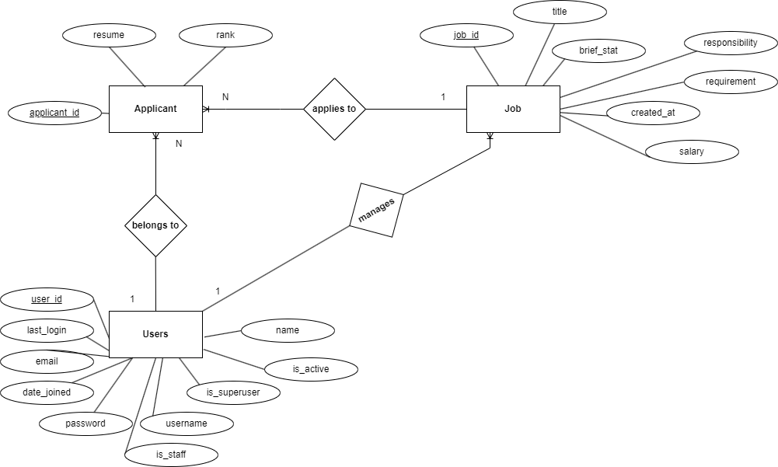

Figure 3.3: ER Diagram of Hire-Hawk Application

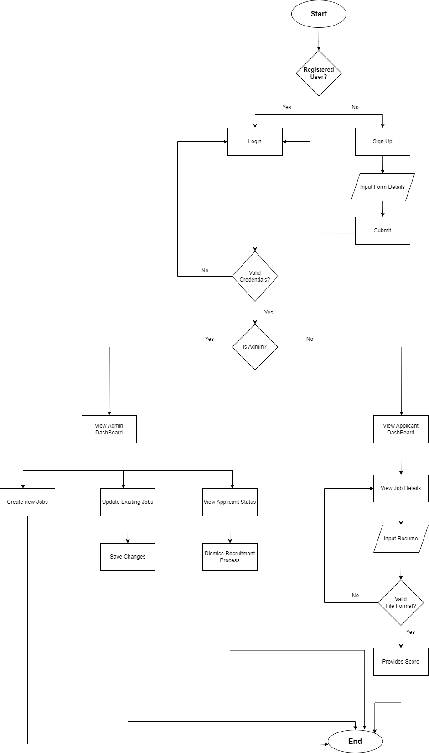

Figure 3.4: Flowchart of Hire-Hawk Application

1. Process Modeling Using DFD

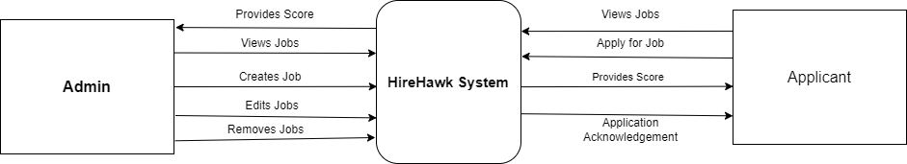

Figure 3.5: Level 0 DFD of Hire-Hawk Application

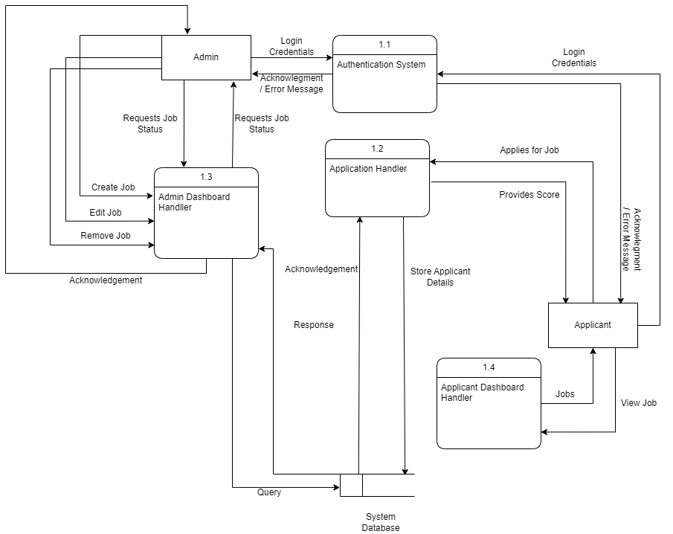

Figure 3.6: Level 1 DFD of Hire-Hawk Application

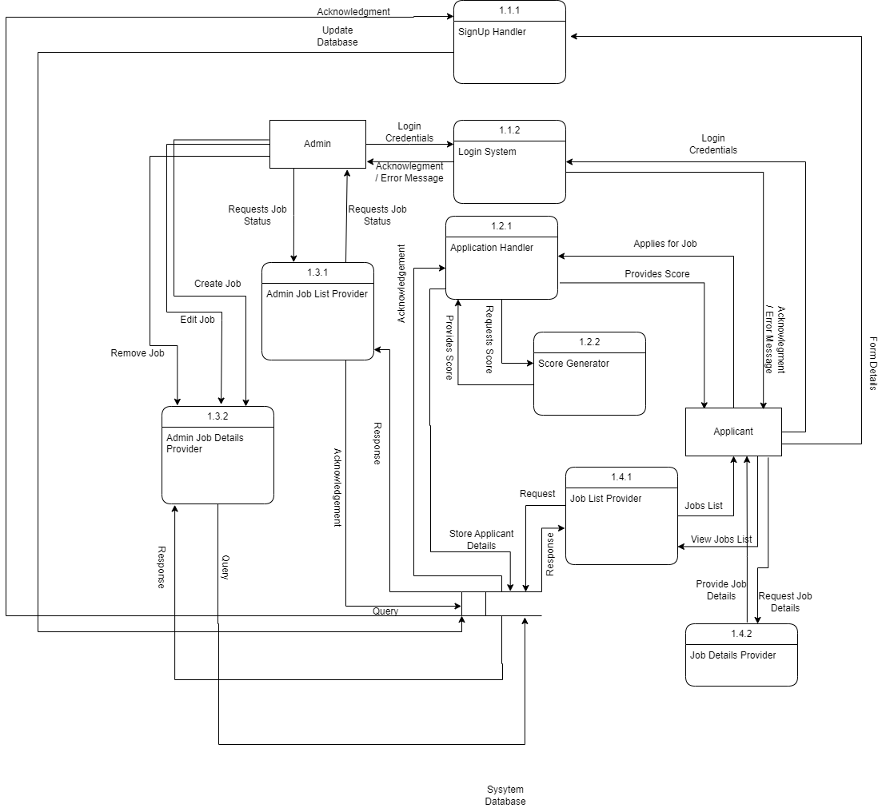

Figure 3.7: Level 2 DFD of Hire-Hawk Application

**Chapter 4: System Design**

## 4.1 Design

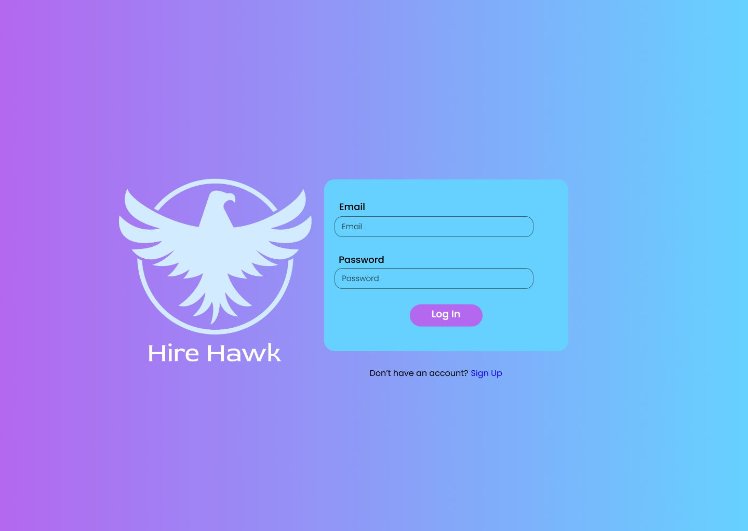Through detailed data modeling like ER diagrams, and process modeling with DFDs, the project establishes a structured and efficient recruitment processes. The design emphasizes user interfaces, such as login pages and dashboards, ensuring a seamless experience.

Figure 4.1: Login Page of Hire-Hawk Application

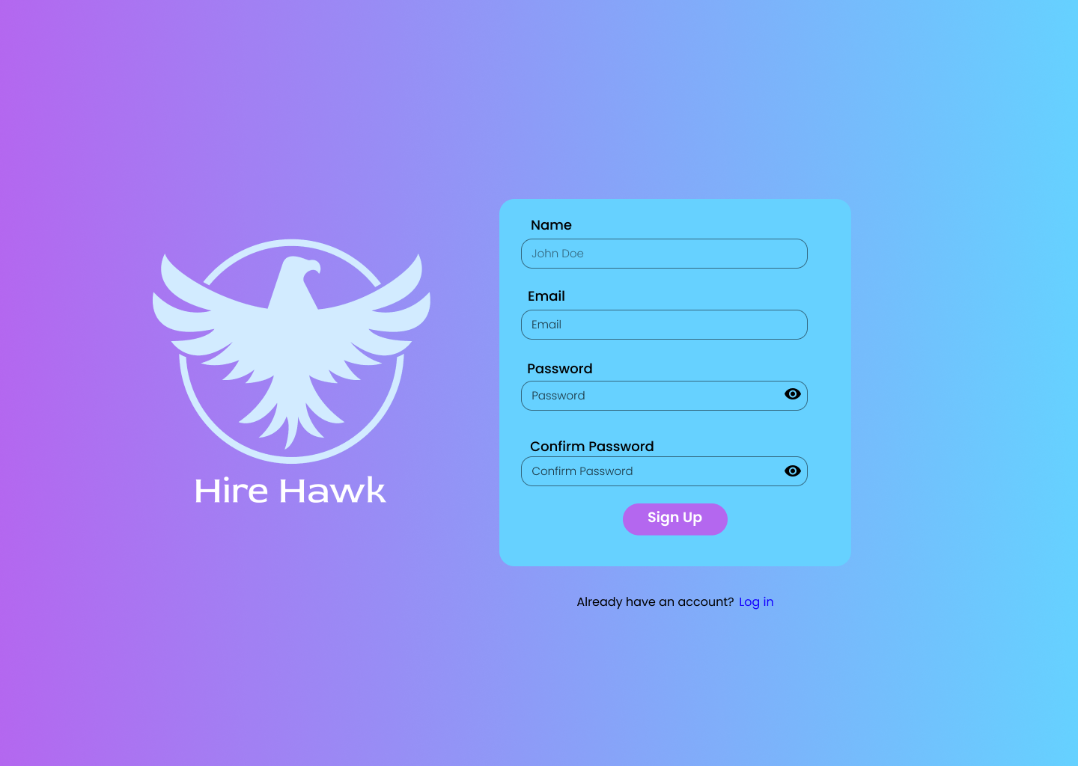

Figure 4.2: Signup page of Hire-Hawk Application

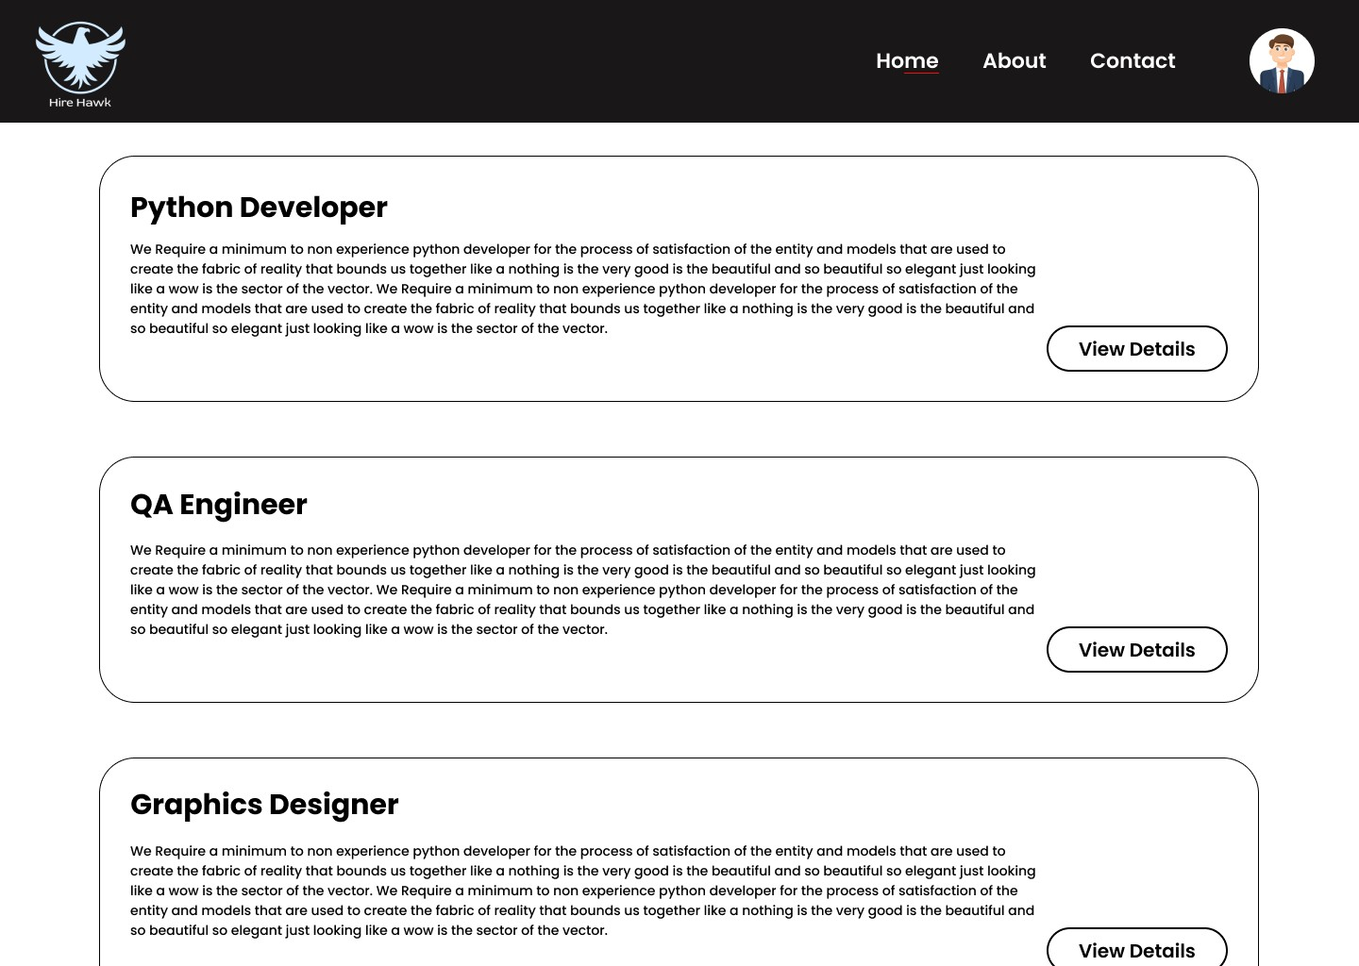

Figure 4.3: Applicant Dashboard page of Hire-Hawk Application

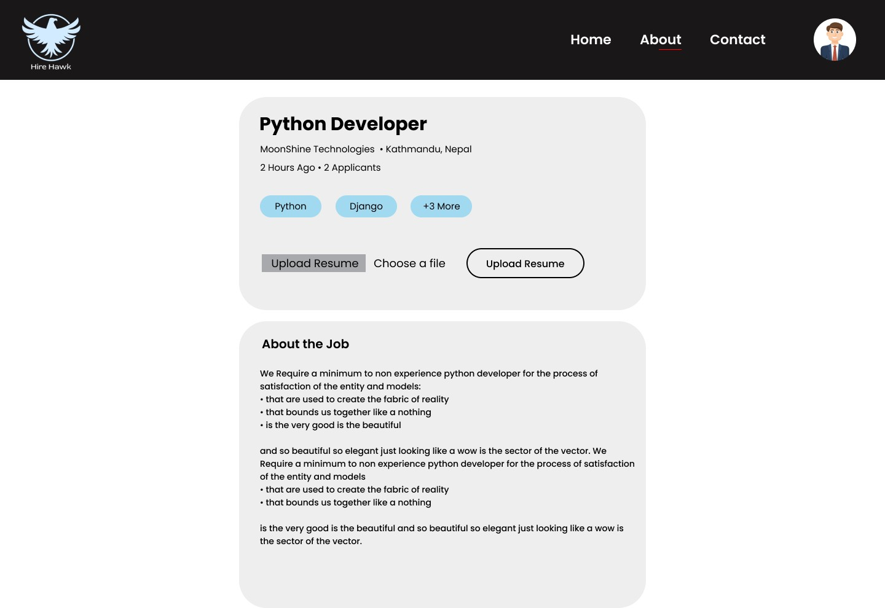

Figure 4.4: About Job page of Hire-Hawk Application

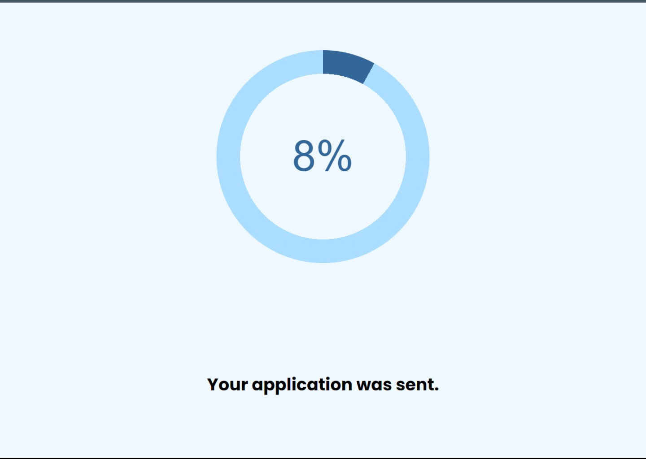

Figure 4.5: Score Guage page of Hire-Hawk Application..

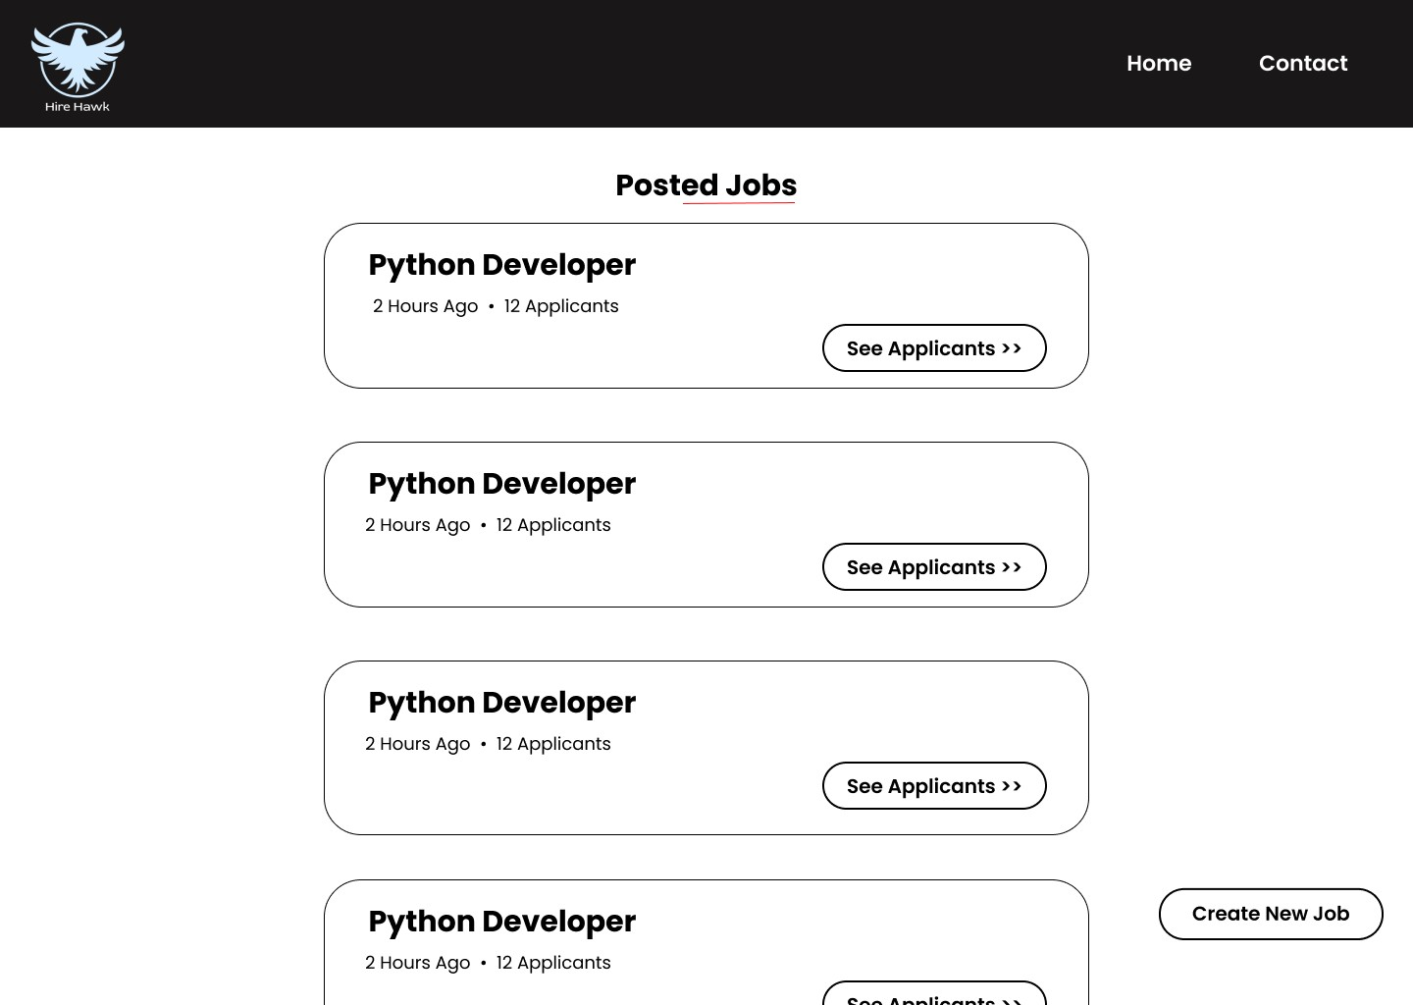

Figure 4.6: Recruiter Dashboard page of Hire-Hawk System.

# References

1. I. Ojanen *et al.*, “Introduction and integration of ucd and scrum methodologies-tools and methods,” Master’s thesis, 2016.
2. C. Daryani, G. S. Chhabra, H. Patel, I. K. Chhabra, and R. Patel, “An automated resume screening system using natural language processing and similarity,” *ETHICS AND INFOR- MATION TECHNOLOGY [Internet]. VOLKSON PRESS*, pp. 99–103, 2020.
3. M. Kocaleva, D. Stojanov, I. Stojanovic, and Z. Zdravev, “Pattern recognition and natural language processing: State of the art,” *Tem Journal*, vol. 5, no. 2, pp. 236–240, 2016.
4. K. D. Carlson, M. L. Connerley, and R. L. MECHAM III, “Recruitment evaluation: The case for assessing the quality of applicants attracted,” *Personnel Psychology*, vol. 55, no. 2, pp. 461–490, 2002.
5. C. Daryani, G. S. Chhabra, H. Patel, I. K. Chhabra, and R. Patel, “An automated resume screening system using natural language processing and similarity,” *ETHICS AND INFOR- MATION TECHNOLOGY [Internet]. VOLKSON PRESS*, pp. 99–103, 2020.
6. C. M. Ross and S. J. Young, “Resume preferences: Is it really “business as usual”?” *Journal of Career Development*, vol. 32, no. 2, pp. 153–164, 2005.
7. H. Braun, “Applying learning-to-rank to human resourcing’s job-candidate matching prob- lem: A case study.” 2017.
8. A. Zaroor, M. Maree, and M. Sabha, “Jrc: a job post and resume classification system for online recruitment,” in *2017 IEEE 29th International Conference on Tools with Artificial Intelligence (ICTAI)*. IEEE, 2017, pp. 780–787.